**El Espada**

**Project Plan**

**Prepared by the Avengers – UIS Force:**

**Avinash Moram**

**Daniel Henderson**

**Zach Parker**

TABLE OF CONTENTS

scope statement 3

tools and standards 4

configuration management plan 4

gantt chart 6

organizational chart 7

itERATIVE AGILE chart 8

**Scope Statement**

The purpose of this project is to create a Windows-based software as a standalone application ready to take online orders for a Mexican restaurant. Throughout the development phase the utilization of the latest JDK, Maven, Spring Boot, H2 database, JavaScript, HTML, CSS, Thymeleaf, and Bootstrap to give the program a unique look. The software will have a unique user interface by displaying a pictorial menu with prices for each item and a summary page with the listed amounts per item. Easy-to-use payment methods to make the online experience much more user-friendly. We, the Avengers – UIS Force, feel confident that the use of the H2 in memory database should make the software easier to maintain in comparison to other databases.

**Tools and Standards**

* **Sprint Tool Suite (IDE) -** <https://spring.io/tools>
* **HTML -**<https://developer.mozilla.org/en-US/docs/Web/HTML>
* **CSS -** <https://developer.mozilla.org/en-US/docs/Web/CSS>
* **JavaScript -** <https://developer.mozilla.org/en-US/docs/Web/JavaScript>
* **BootStrap -** <https://getbootstrap.com/>
* **Spring Boot -** <https://spring.io/projects/spring-boot>
* **Maven -** <http://maven.apache.org/>
* **JPA Hibernate -** <https://hibernate.org/orm/>
* **H2 Database -** <https://www.h2database.com/html/main.html>
* **Thymeleaf -** <https://www.thymeleaf.org/>
* **Tomcat -** <http://tomcat.apache.org/>

**Java coding standards** 

**Configuration Management Plan**

The configuration plan that was chosen for the Avengers – UIS Force was using Github as a repository. This repository can be found at <https://github.com/zkparker/Software-Engineering-Capstone>. This turned out to be the best way for the developers on the team to work together and not overstep one another. Since the developers on the team worked at different times, this insured that each change was captured.

Multiple branches were used during development to keep track of each iteration. The branches used were Dev, Test, and Master. The dev branch was the first branch used during development. Once the system was to a point that it was ready to be in testing, the changes were then merged to the test branch. This branch was used during testing to verify everything was as desired. After testing, the final move was from the test branch to the master branch. The team also used Trello as a resource for keeping track of each task. Using Trello greatly enhanced the team’s collaboration. A snapshot of the team’s Trello board can be seen below:

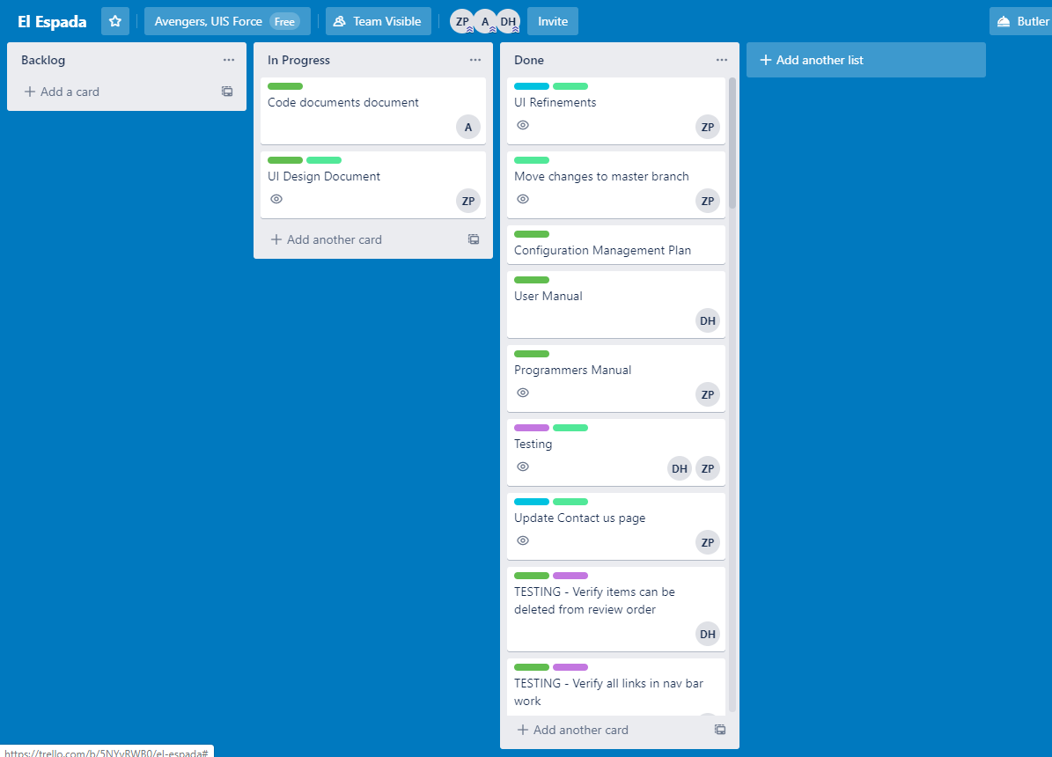

**Gantt Chart**

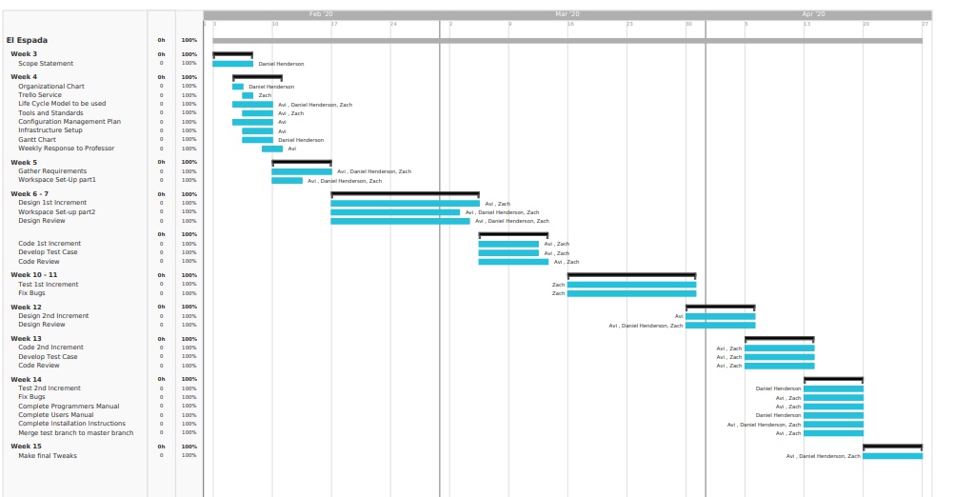

**ORGANIZATIONAL CHART**

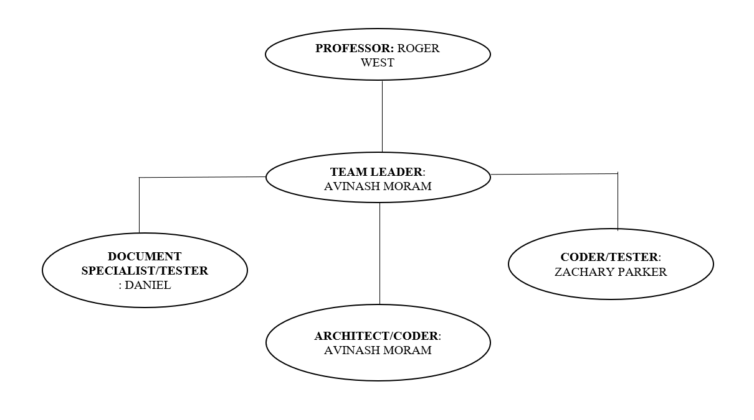

**ITERATIVE AGILE CHART**

Project

Implementation

Evaluation

Planning

Design

Coding

Verification

Requirements

Initialization